2025 SAE Formula Electric Guidelines for Submission Necessary for Use of Team Built Ready to Move (RTM) Indicator

FMVSS 108 has many different compliance requirements. One of the requirements is projecting a minimum amount of light forward of the indicator lamp. For those teams trying to utilize a team built RTM indicator, they must submit some testing data and a picture of the indicator’s projected light pattern in order to have their ESF accepted.

What you will need:
- Light Meter that can read LUX (i.e. luminous flux) to the tenth of a digit
- Measuring Tape (Inelastic String with Distance Marking can be used)
- Power Supply that can provide 12.8 V to your indicator
- Dark Room (doing the measurement at night with lights off)
- Camera
- Screen/White wall/Poster Board

NOTE: All of the certified FMVSS 108 indicator lamps that were tested to establish this testing criteria utilize 3 LED’s to meet the requirements.

Background
The testing requirements for photometry in FMVSS 108 requires a laboratory grade light meter capable of measuring very low levels of light. A modified version of the testing procedure which will be considered acceptable is provided below. This procedure has been modified to test at a closer distance allowing reasonable results with lower cost light meters.

Light Meter Minimum Specifications
- Measurement Range that has 0.1 Lux or 0.01 Footcandle
- Accuracy of 3% or less for the above Measurement Range
- Sampling Rate of at least 1 Hz
Having a separate light collection unit (i.e. on a tether) and readout display is very helpful in obtaining accurate measurements while not blocking a portion of the incident light.

Suggested Light Meter - ~$35
Amazon.com: Dr.meter LX1330B Digital Illuminance Light Meter, 0-200,000 Measurement Range Lux Meter : Electronics
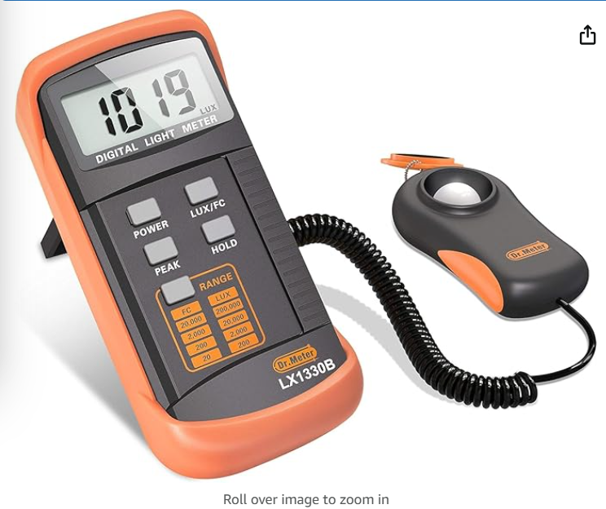
Intensity Measurements
You need to acquire 9 different Luminous intensity measurements at 24” from your indicator. Set the light meter to the lowest measurement range (i.e. at least tenths of LUX readout). The collection face of the light meter should be normal to the ray of light coming from the center of the indictor to the current measurement point (this will provide the largest luminous flux). With the lights off and the light meter positioned at one of the required measurement points, record the luminous flux (LUX).

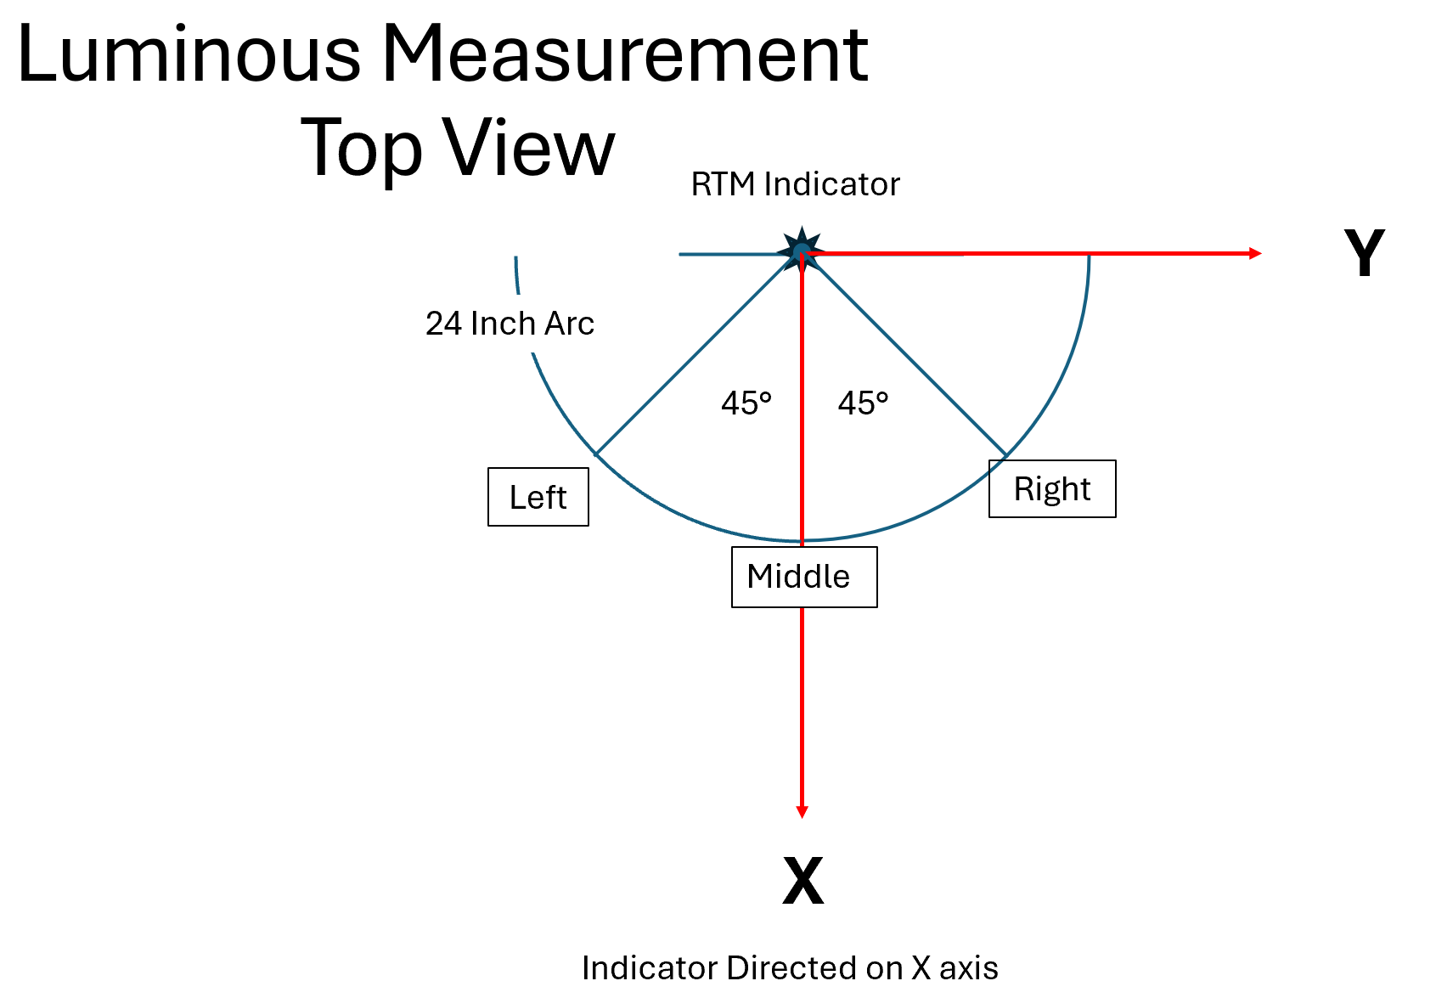

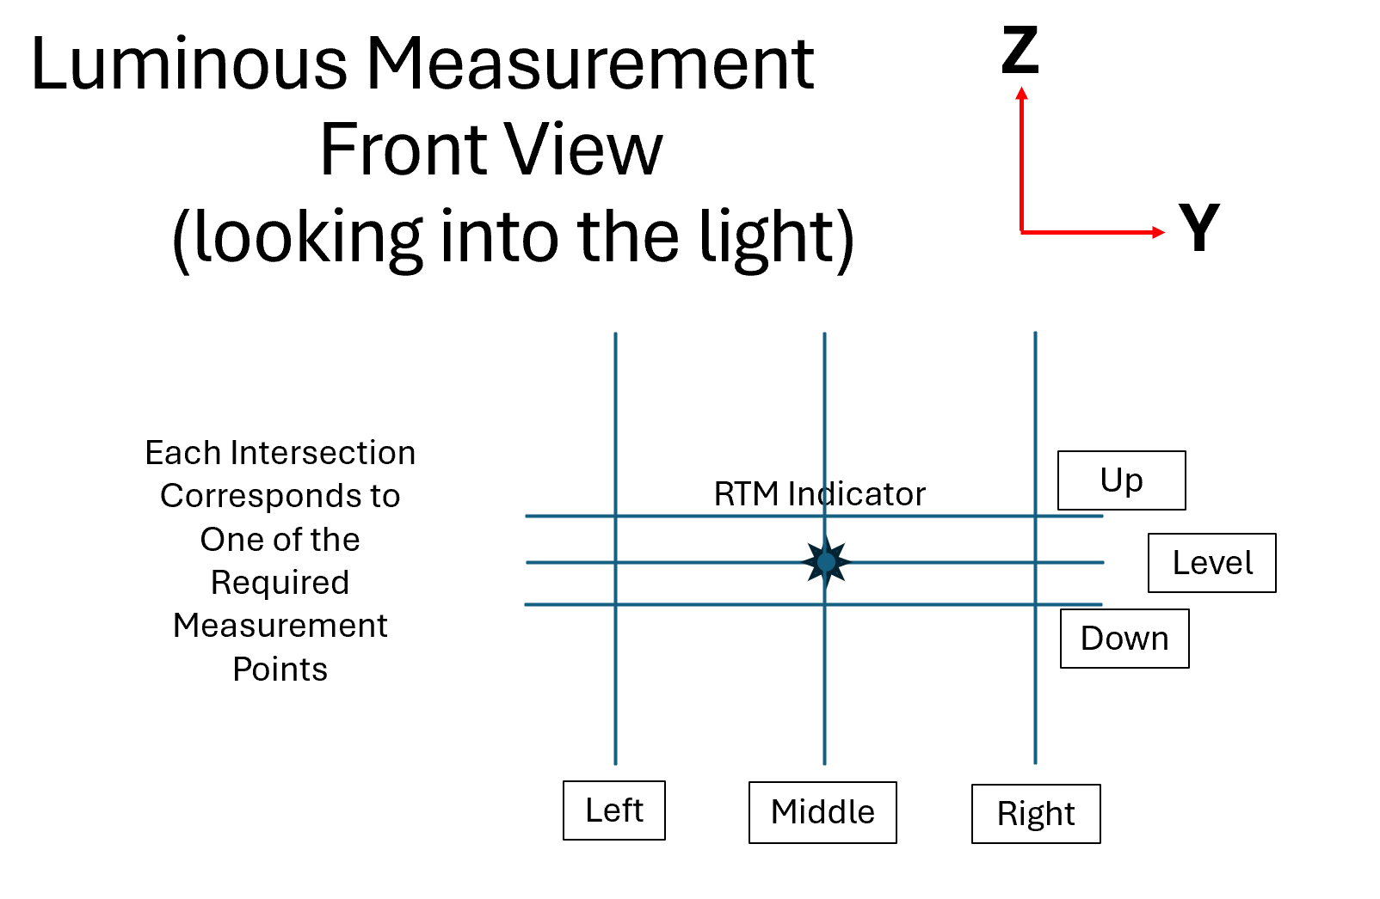

Coordinates for Measurement Locations

 |  | Horizontal Position
 | Left | Middle | Right
Vertical Position
Up | (16.713, -16.713, 4.168) | (24, 0, 4.168) | (16.713, 16.713, 4.168)
Level | (17, -17, 0) | (24, 0, 0) | (17, 17, 0)
Down | (16.713, -16.713, -4.168) | (24, 0, -4.168) | (16.713, 16.713, -4.168)
 | (x, y, z) in inches

*Light Collector should be normal to a line between the center of the ready to move light and the measurement location. This will provide the maximum value and is what FMVSS 108 requires.
SUBMISSION REQUIREMENTS
Complete the Team Built RTM Testing Results for Submission to SAE spreadsheet then add a link into your teams’ ESF template on the Shutdown Circuit tab; add link to the Additional Comments area under the titled Ready to Move Light Schematic Shows.

Below, for reference, is what needs to be submitted on the spreadsheet
1. Populate this Results Table
All Units in LUX
 |  | Horizontal Position
 | Left | Middle | Right
Vertical Position
Up
Level
Down
* Lux = 10.76391 * Footcandle

2. Brand and Model of Light Meter, Measurement Range, Accuracy and Sampling Rate

3. Image of Indicator Projected onto Screen/White Wall
With the lights off, provide an image of your indictor’s light distribution. An example of the image required is shown below.
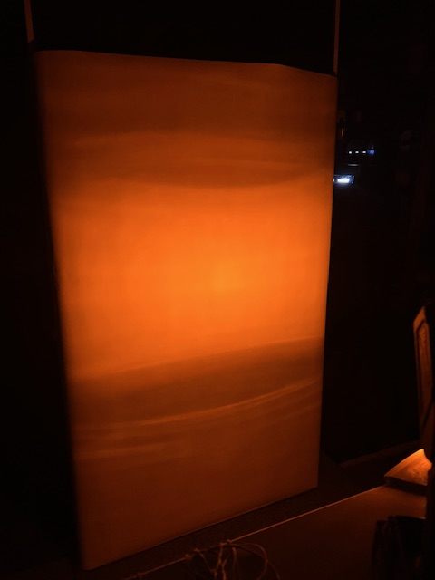
AT COMPETITION

Any team built light that does not appear to meet the standards MAY be retested on-site at the discretion of the Technical Inspector.

Other FMVSS 108 requirements (vibration, corrosion, dust, moisture) will also be evaluated at Technical Inspection. Vibration and corrosion will be a visual inspection while the dust and moisture will be evaluated during the rain test.

IT IS HIGHLY RECOMMENDED that your team has in its possession 2 approved FMVSS 108 amber indicators and appropriate mounting hardware in the case your team built indicator is NOT approved.

