The specific schedule for presentations will be posted soon. Some last-minute details are being finalized, but we should have posted very soon. In the meantime, please be aware of where and how to get your access links. They will be posted within the document submission area where you submitted your presenter form.
Pictured below are steps of how/where to obtain your access link doc:
- Login to your account at fsaeonline.com and click the ‘My Team’s Report & Document Submissions’ link on your Team Member Menu.


- Next, click the ‘Has New Comment’ icon next to the Hopin Presenters Form Submission.
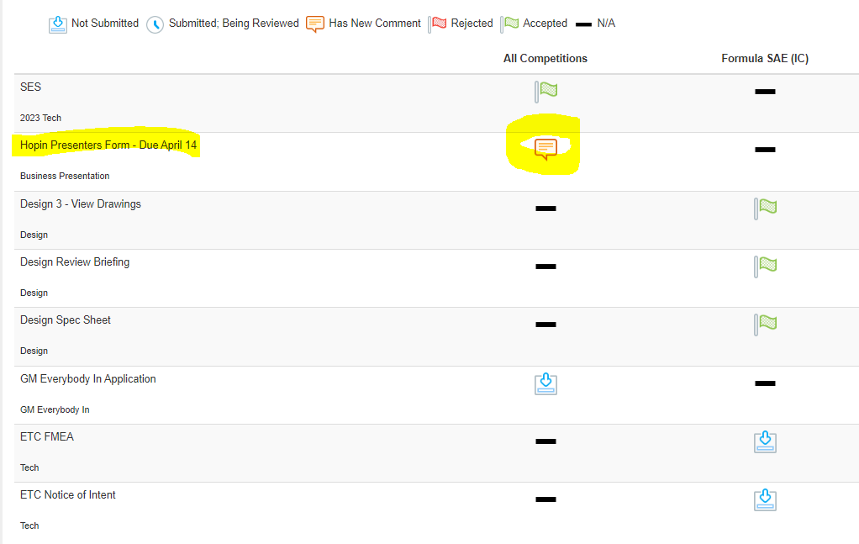
- Scroll down to the report judge comment for additional information and the attachment that will include your team’s access link to your presentation room for the 11th.



