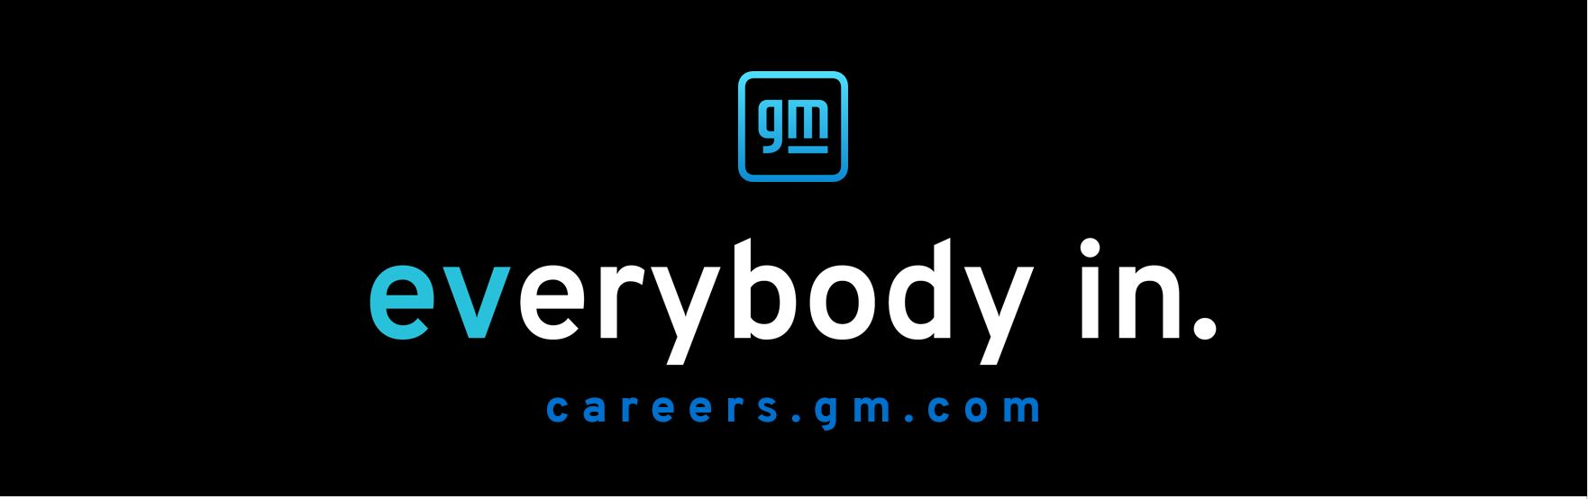

The Everybody In Award
Sponsored by GM
Prize: One Pre-Paid Registration Voucher ($2550 value)

GM is focused on advancing an all-electric future that is inclusive and accessible to all. We are at an inflection point for society, and GM’s Everybody In campaign is a call to action that challenges convention and says we’re all in this together.

GM would like to recognize the team that best reflects the Everybody In campaign and values. Please complete this submission form and upload it to FSAEonline.com.

Only one submission is allowed per team. A team representative must be present at the award ceremony to win.

Learn more about our mission and Everybody In from our company stories and at GM.com.

Team Name
Please delete this text and enter your response here.

University Name (include the campus if your university system has multiple campuses with teams)
Please delete this text and enter your response here.

Faculty Advisor Name(s)
Please delete this text and enter your response here.

Faculty Advisor Email(s)
Please delete this text and enter your response here.

What does “Everybody In” mean to your team? (900 character limit)
Please delete this text and enter your response here.

At General Motors, safety is at the center of everything we do. What does your team do to make sure your team members return home safely every day? (900 character limit)
Please delete this text and enter your response here.

General Motors is committed to an all-electric future.
- If your team currently competes with an internal combustion engine (ICE), tell us about how your team facilitates a zero-emissions future. What challenges have you encountered?
- If your team currently competes with an electric vehicle, tell us about why you switched to electric and why you stay committed to an electric propulsion system. What challenges did you face while making your switch and what motivated you to overcome them?
(900 character limit)
Please delete this text and enter your response here.

General Motors aspires to be the most inclusive company in the world, and we are committed to helping create a clean, safe, and equitable world for all. How are you working to make your team more inclusive? (900 character limit)
Please delete this text and enter your response here.

If you would like, you may provide a team photo. A team photo is not required and is not scored as a part of your submission. You may resize your photo as needed to fit the page.

