Coversheet
The Coversheet must contain the following:
- Heading “Electrical System Form FSAE-E 2019”
- University and Team Name
- Car number
Feel free to add team logo, car picture, and the like.

Requirements (delete this section after you have read and understood it):
Complete all sections and tables of the ESF. If a section is not applicable to your design state that in the document, do not delete any sections.
Remove instructions (orange) from document as you complete the sections.
Provide hyperlinks to all datasheets.
If you are unsure with respect to feedback of the reviewer, do not hesitate to ask through FSAEOnline.
Parts of the ESF which are changed because of reviewer’s feedback must be marked in red.
Following these guidelines will guarantee a swift review process.

Table of Contents
1 System Overview 7
2 Tractive System Schematics 7
2.1 Tractive System Schematic (Power Electronics ONLY) 7
2.2 Fusing Diagram 8
3 Shutdown Circuit 9
3.1 Shutdown Circuit Schematic 9
3.2 Wiring 10
3.3 IMD 11
3.4 Brake System Plausibility Device 12
3.5 Battery Management System 13
4 Safety Systems 13
4.1 TSAL 13
4.2 Measurement Points 14
4.3 HVD 16
4.4 Ready to Drive Sound 17
4.5 Discharge Circuit 17
5 Accumulator 18
5.1 Accumulator Schematic 18
5.2 Cells 20
5.3 Segments 22
5.4 Precharge Circuit 23
5.5 BMS 24
5.6 AIR 26
5.7 Accumulator Indicator 26
5.8 Mechanical 27
5.9 Charging 27
6 Motor Controller 29
6.1 Controls Architecture/Torque Security 29
6.2 Galvanic Isolation 29
7 Other Items 29
7.1 Energy Meter 29
7.2 Firewall 30
7.3 Grounding 30
7.4 Other Components 30
8 Appendix 31
8.1 SDS (MSDS) of accumulator cell 31

Table of Figures
Figure 1-1 - System Block Diagram 7
Figure 2-1 - HV System Schematic 8
Figure 3-1 - Shutdown Circuit Schematic 10
Figure 3-2 - Shutdown Circuit Switch Locations 10
Figure 3-3 - IMD Latch Circuit Schematic 11
Figure 3-4 - BSPD Schematic 12
Figure 3-5 - BSPD Component Location 13
Figure 4-1 - TSAL Circuit Schematic 14
Figure 4-3 - TSAL Component Locations 14
Figure 4-4 - Measurement Point Location 15
Figure 4-5 - TSMP Protection Resistor Location 16
Figure 4-6 - HVD Location 17
Figure 4-7 - Discharge Circuit Component Locations 18
Figure 5-1 - Accumulator Schematic 20
Figure 5-1 - Cell Connection Detail 21
Figure 5-1 - Cell Mounting in Accumulator 22
Figure 5-2 - Maintenance Plug Locations 23
Figure 5-3 - Precharge Circuit Location 24
Figure 5-4 - Location of Temperature Sensors 25
Figure 5-5 - BMS Location 26
Figure 5-6 - Schematic of Accumulator Indication 26
Figure 5-7 - AIR and Fuse Separation 27
Figure 5-8 - Chrarging Shutdown Circuit Schematic 28
Figure 5-9 - Charging TS Schematic 28
Figure 6-1 - Toque Control Signal Path 29
Figure 7-1 - Energy Meter Location 29
Figure 7-2 - Firewall Location 30

Table of Tables
Table 1-1 - High Level Specifications 7
Table 2-1- Fuse Tree Diagram 8
Table 2-2 - Fuse Specifications 9
Table 2-3 - Conductor Specifications 9
Table 2-4- Connector Specifications 9
Table 3-2 - Shutdown Circuit Loads 10
Table 3-5 - IMD Specifications 11
Table 3-6 - BSPD Current Sensor Specifications 12
Table 3-7 - BSPD Operation Details 12
Table 4-1 - TSAL Specifications 13
Table 4-2 - Measurement Point Specifications 14
Table 4-3 - TSMP Protection Resistor Specifications 15
Table 4-4 - HVD Specifications 16
Table 4-5 - RTDS Specifications 17
Table 4-6 - Discharge Resistor Specifications 18
Table 4-7 - Discharge Relay Specifications 18
Table 5-1 - Cell Specifications 21
Table 5-2 - Segment Specifications 22
Table 5-3 - Maintenance Plug Connector Specification 22
Table 5-4 - Precharge Resistor Specifications 23
Table 5-5 - Precharge Relay Specifications 23
Table 5-6 - Temperature Sensor Specifications 24
Table 5-7 - BMS Setpoints 25
Table 5-8- AIR Specifications 26
Table 5-9 - Charger Specifications 27
Table 7-1 - Firewall Specifications 30

Abbreviations
AIR – Accumulator Insulation Relay
AMS- Accumulator Monitoring System
BMS- Battery Monitoring System
BOTS – Brake-Over-Travel-Switch
BSPD – Brake System Plausibility Device
GLV – Grounded Low Voltage
GLVMP – Ground Low Voltage Measurement Point
HV – High Voltage
IMD – Insulation Monitoring Device
TS – Tractive System
TSAL – Tractive System Active Light
TSMP – Tractive System Measurement Point

System Overview
Include brief description of vehicle (1 paragraph). Complete the information in the table below.

Maximum Tractive System Voltage: | 1000VDC
Nominal Tractive System Voltage: | 960VDC
Grounded Low Voltage System Voltage: | 2.5VDC
Number of Accumulator Containers: | 2
Total Accumulator Capacity: | 20kWhr
Motor Type: | AC Induction
Number of Motors: | Total 4, one per wheel
Maximum Combined Motor Power: | 150kW
Table 1-1 - High Level Specifications
Insert a system overview block diagram showing major electrical components and system interactions
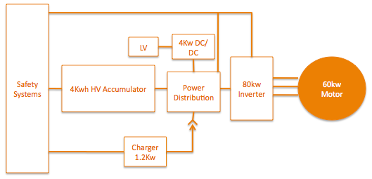
Figure 1-1 - System Block Diagram

Tractive System Schematics

Tractive System Schematic (Power Electronics ONLY)
Insert a large (full page) schematic of the HV system. This schematic should focus on the components that are not within the accumulator. Provide boxes and 1st level interfaces, when details will be provided later in this document. Some detail of components within the accumulator may be included for better understanding (ie AIRs).
Figure must include the following:
- Wire Size (AWG or mm²)
- Relative fuse location (end of wire vs middle)
- Fuse rating (Amperage and Voltage)
- Motor controller (1st level interfaces...inputs & outputs)
- Motor
- Inline connectors and interfaces for charging
- TSMP and relative current limiting resistor locations
- Show enclosures as dashed lines
The figure must include the following if not within the accumulator
- IMD
- DCDC converter if used
- Precharge and Discharge circuit
- Energy Meter
- HVD

Figure 2-1 - HV System Schematic

Fusing Diagram
Include a fusing tree diagram like the one shown below.
Table 2-1- Fuse Tree Diagram

Fuse Specifications
Complete the information in the table below.
Fuse Location | Current Rating | Voltage Rating | Interrupt Rating | Datasheet
Table 2-2 - Fuse Specifications

Conductor Specifications
Complete the information in the table below.
Conductor Location | Size | Voltage Rating | Ampacity | Rating of fuse providing protection | Temperature Rating | Datasheet
Table 2-3 - Conductor Specifications

Connector Specifications
Complete the information in the table below.

Connector Location | Ampacity | Voltage Rating | Includes Interlock | Accepted wire gauge | Wire gauge connected | Datasheet
Table 2-4- Connector Specifications

Shutdown Circuit

Shutdown Circuit Schematic
Insert a large (full page) schematic of the shutdown circuit.
The schematic must include the following:
- All shutdown circuit switches/devices (indicate Normally Open or Closed )
- Safety interlocks associated to connectors or HVD
- BMS connection to shutdown circuit
- BSPD connection to shutdown circuit
- IMD connection to shutdown circuit (include path from output of IMD OKHS to shutdown circuit, additional detail may be provided in second figure)
- BOTS
- Inertia switch
- AIR coils including resistance of coil and voltage rating or economizer detail
- Precharge relay coil
- GLV battery
- Fuse(s)
- Wire Size (AWG or mm²)
Figure 3-1 - Shutdown Circuit Schematic

Switch Locations
Provide CAD-rendering(s) showing the shutdown circuit parts. Mark the parts in the renderings, if necessary. Include your design intent wire harness routing path.
Figure 3-2 - Shutdown Circuit Switch Locations

Wiring

Shutdown Circuit Current
Complete the information in the table below.
Total Number of AIRs: | 10
Current per AIR: | 0.5A
Additional parts consumption within the shutdown circuit: | 2A
Total current: | 7A
Table 3-1 - Shutdown Circuit Loads

IMD

IMD Specifications
Complete the information in the table below.
Make / Model | Bender IR12345
Supply voltage | 2VDC
Environmental temperature range: | 45..55°C
Self-test interval: | every 20 ms
High voltage range: | DC 0..10V
Set response value: | 30kΩ (500Ω/Volt)
Max. operation current: | 500mA
Approximate time to shut down at 50% of the response value: | 80s
Datasheet | Datasheet
Table 3-2 - IMD Specifications

IMD Fault Latching
Include schematic showing how latching circuit for IMD operates. Also include the IMD status indicator in the figure.
Figure 3-3 - IMD Latch Circuit Schematic

IMD Location
Describe the location of the IMD.
Describe the location of the IMD indicator.
Describe the location of the reset button or include a CAD rendering or photograph to show its location.

IMD Demonstration
Describe numbered steps of how to demonstrate that the IMD can detect a fault at competition.

Brake System Plausibility Device

BSPD Current Sensor
Complete the information in the table below.
Make / Model: | Acme Sensor Co. ABC123
Current input range: | +/- 150A
Output range: | 0-50V
Datasheet: | Datasheet
Table 3-3 - BSPD Current Sensor Specifications

BSPD Setpoint
Complete the information in the table below.
Trip Current | 62A
Current sensor output @Trip Current | 35V
Delay time | 200ms
Table 3-4 - BSPD Operation Details

BSPD Schematic
Include schematic of BSPD. Clearly show current sensor input, brake input and shutdown circuit output. Be sure schematic includes details addressing latching and timing.
Figure 3-4 - BSPD Schematic

BSPD Location
Describe the location of the BSPD and reset button or include a CAD rendering or photograph to show its location.
Figure 3-5 - BSPD Component Location

BSPD Demonstration
Describe the method you will use to demonstrate the BSPD device at competition.

Battery Management System

BMS Faults
Describe what faults/conditions will cause the BMS to open the shutdown circuit.

BMS Fault Latching
Describe the method used to latch the BMS fault, include a schematic if appropriate.
- Describe the location of the reset button or include a CAD rendering or photograph to show its location.

BMS Demonstration
Describe numbered steps of how you could demonstrate proper operation of the BMS at competition

Safety Systems

TSAL

TSAL Specifications
Complete the information in the table below.
Make/Model: | Flashy Light Co. SprBrt12
Color: | Purple
Flash Rate: | 18Hz
Powered By: | GLV
Controlled By: | TS
TS Turn On Voltage: | 60
TS Turn Off Voltage: | 58
Table 4-1 - TSAL Specifications

TSAL Schematic
Include a schematic showing the control circuit for the TSAL. The schematic should include all components from HV sense input to light. If team designed PCB is used with TS and GLV circuits provide CAD rendering or photograph showing spacing for TS/GLV separation.
Figure 4-1 - TSAL Circuit Schematic

TSAL Location
Provide CAD-rendering(s) showing the TSAL parts. Mark the parts in the renderings, if necessary.
Figure 4-2 - TSAL Component Locations

Measurement Points

Measurement Point Specifications
Complete the information in the table below.
Make / Model: | Acme Connect Co P88943
Voltage Rating: | 600V
Datasheet: | Datasheet
Table 4-2 - Measurement Point Specifications

Measurement Point Location
Provide CAD-rendering(s) showing the measurement points. Mark the parts in the renderings, if necessary.
Figure 4-3 - Measurement Point Location

Measurement Point Protection
Describe how the backs of the TSMPs are protected from being touched.
Describe how the fronts of the TSMPs are protected from rain entering and how the cover is removed for testing.

TSMP Protection Resistor
Complete the information in the table below.
Make / Model: | ResistorsRUs R10K5W
Resistance: | 10,000Ω
Voltage Rating: | 1000V
Power Rating: | 5W
Datasheet: | Datasheet
Table 4-3 - TSMP Protection Resistor Specifications

TSMP Protection Resistor Location
Provide CAD-rendering(s) showing the measurement point protection resistor location. Mark the parts in the renderings, if necessary.
Figure 4-4 - TSMP Protection Resistor Location

TSMP Demonstration
Describe numbered steps you would take to provide measurements of: Discharge Resistance value, Current Limit Resistor values, TS voltage. (veh off), and TS voltage (veh on).
Include any safety precautions.

HVD

HVD Specifications
Complete the information in the table below.
Make / Model: | Best HVD Company HVD111
Ampacity: | 45A
Voltage rating: | 1000V
Datasheet: | Datasheet
Table 4-4 - HVD Specifications
If the HVD is not an “off the shelf design” describe how it works and include a CAD rendering.
Which contacts make/break first (high current or interlock)?

HVD Location
Provide CAD-rendering(s) showing the HVD. Mark the parts in the renderings, if necessary.
Describe the physical distance (cm) from the road surface to the bottom of the HVD.
Figure 4-5 - HVD Location

HVD Connections
Describe how the electrical connections are made to the HVD. How are these protected from rain and touch?

HVD Demonstration
Describe the method you would use to install and remove the HVD at competition. Include any safe handling instructions ex. Not to be installed while manually pushing vehicle. Describe if method of removal allows for the use of High Voltage PPE. Include any details regarding dust covers, dummy plugs, or special handling of HVD when not installed.

Ready to Drive Sound

RTDS Device and Control
Describe how the RTDS is controlled (what device controls it). Complete the information in the table below.
Make / Model: | Loud Alerts 12VBzr95
Control Voltage: | 14V
SPL at 2m: | 86 dBA
Datasheet: | Datasheet
Table 4-5 - RTDS Specifications

Ready to Drive Mode Demonstration
Describe numbered steps required to put the vehicle into ready to drive mode.

Discharge Circuit

Discharge Circuit Component Specifications
Complete the information in the tables below.
Make / Model: | ResistorsRUs 500R10W
Resistance: | 500Ω
Voltage: | 800V
Power: | 10W
Power @15sec: | 80W
Datasheet | Datasheet
Table 4-6 - Discharge Resistor Specifications
Make / Model: | RelayCo ABCD876
Contact Current Rating: | 1A
Contact Voltage Rating: | 750V
Datasheet: | Datasheet
Table 4-7 - Discharge Relay Specifications
What is the capacitance of the TS bus (include DCDC converter if part of design)? How long does it take to discharge to <60V?

Discharge Circuit Location
Describe location or provide CAD-rendering(s) or photographs showing the discharge components. Mark the parts in the renderings, if necessary.
Figure 4-6 - Discharge Circuit Component Locations

Discharge Circuit Control
Describe how the discharge relay is controlled.

Discharge Circuit Demonstration
Describe numbered steps you would use to demonstrate that TS voltage has been discharged to <60vdc.

Accumulator

Accumulator Schematic
Insert a large (full page) schematic of the accumulator HV system.
Figure must include the following:
- Maintenance plugs
- Main traction loop wires (include size and details of shielding & termination)
- Details of how cells are interconnected (can be done in a secondary detail view)
- Fuse (include relative location, current and voltage rating)
- Connectors (include amperage and voltage rating...also show any additional pins for interlocks)
The figure must include the following if within the accumulator
- IMD
- DCDC converter if used
- Precharge and Discharge circuit
- Energy Meter
- HVD
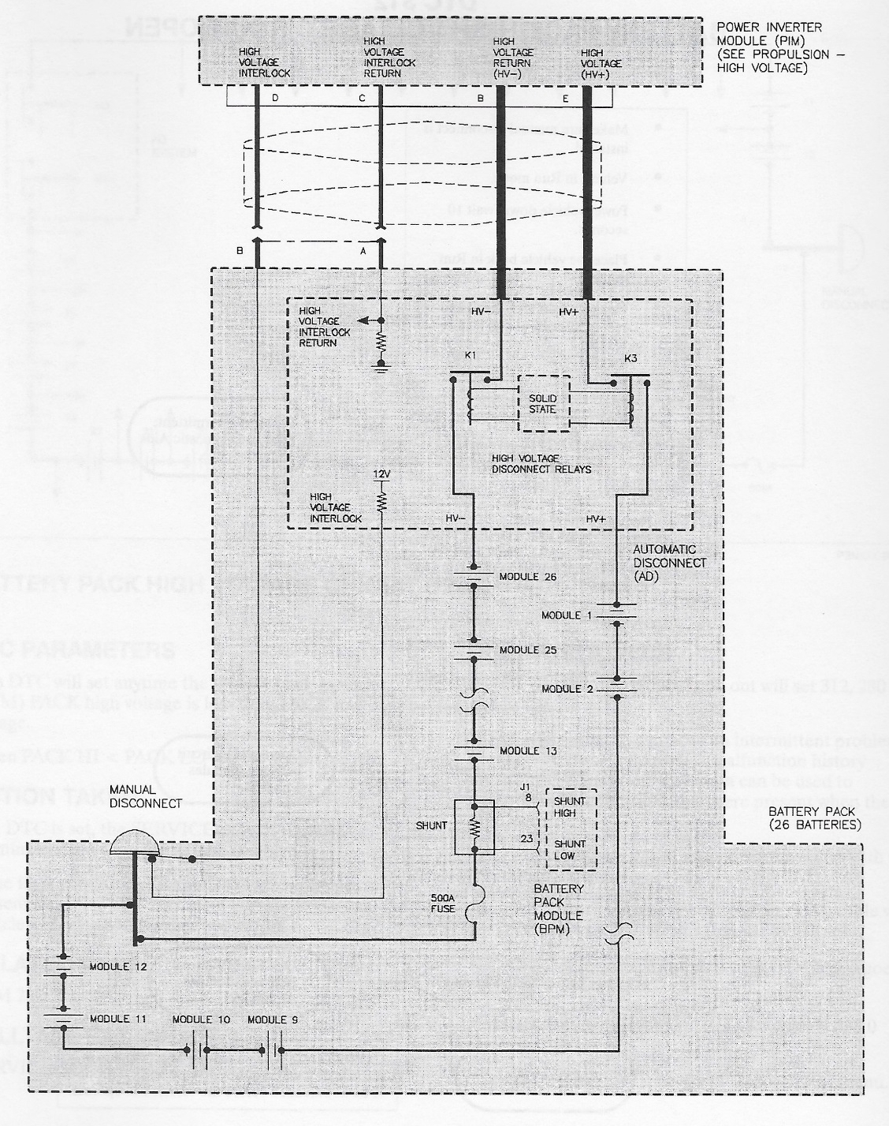
Figure 5-1 - Accumulator Schematic

Cells

Cell Specifications
Complete the information in the table below.
Cell Make / Model / Style : | Kokam XYZ- pouch, cylindrical,or metal can
Cell nominal capacity: | 5.4 Ah
Maximum Voltage: | 4.2 V
Nominal Voltage: | 3.7V
Minimum Voltage: | 2.8V
Maximum output current: | 20C for 10s
Maximum continuous output current: | 15C
Maximum charging current: | 5C
Maximum Cell Temperature (discharging) | 65°C
Maximum Cell Temperature (charging) | 55°C
Cell chemistry: | LiFePO4
Table 5-1 - Cell Specifications

Cell Electrical Configuration
Describe how the cells are connected electrically. Series first vs parallel first, groups of parallel cells in series, etc.

Cell Connections
Describe how the electrical connections are made to the cells (welded/bolted/clamped)? Define what kind of weld (resistance/laser), what kind bolt(copper w/deforming nut), material of clamp. If bus bars are used what is the cross sectional area and ampacity?

Include CAD rendering.
Figure 5-2 - Cell Connection Detail

Parallel Cell Overcurrent Protection
Describe how EV.8.1.5 and EV.8.1.6 (if applicable) are met. Note that EV.8.1.5 requires per cell overcurrent protection if cells are connected in parallel. This can be done with fuses or fusible links. If fusible links are used, then EV.8.1.6 applies. If team designed fusible links are used then provide testing data and ampacity rating (calculated and measured).

Cell Mounting
Describe how cells are mounted in the accumulator container. Provide CAD rendering or photograph to show mounting mechanism. Provide details on how cells are retained without compromising insulation and supporting isolation integrity.
Figure 5-3 - Cell Mounting in Accumulator

Segments

Segment Specifications
Complete the information in the table below.
# of Segments: | 5
Cells per segment: | 15
Cell configuration in segment: | 5S3P
Energy in segment: | 2.8MJ / 0.78 kWhr
Table 5-2 - Segment Specifications

Segment Physical Isolation
Describe how the segments are physically isolated from one another, and how design provides a safe environment from dropped tools.

Maintenance Plugs
Describe how maintenance plugs are implemented in between the segments. If off the shelf components are used provide link to datasheet.
Complete the information in the table below.
Make / Model: | Connector Co. SQV436
Ampacity: | 180A
Voltage: | 750V
Datasheet: | Datasheet
Table 5-3 - Maintenance Plug Connector Specification
Provide CAD rendering or photograph to show location and implementation of maintenance plugs.
Figure 5-4 - Maintenance Plug Locations

Maintenance Plug Positive Locking
Describe how positive locking is provided for maintenance plugs such that they cannot unintentionally come loose.

Maintenance Plug Unique Configuration
Describe how maintenance plugs are designed such they cannot be installed or removed incorrectly.

Maintenance Plug Demonstration
Describe numbered steps you would use to demonstrate the removal/installation of maintenance plugs while wearing High Voltage PPE. What PPE is required?

Precharge Circuit

Precharge Circuit Component Specifications
Complete the information in the tables below.
Make / Model: | ResistorsRUs 500R01W
Resistance: | 500Ω
Voltage: | 650V
Power: | 0.1W
Power @15sec: | 1W
Datasheet | Datasheet
Table 5-4 - Precharge Resistor Specifications
Make / Model: | RelayCo ABCD876
Contact Current Rating: | 1A
Contact Voltage Rating: | 750V
Datasheet: | Datasheet
Table 5-5 - Precharge Relay Specifications

Precharge Circuit Location
Provide CAD rendering(s) or photographs showing the precharge components. Mark the parts in the renderings, if necessary.
Figure 5-5 - Precharge Circuit Location

Precharge Circuit Controls
Describe how the precharge is controlled. What is the bus capacitance? How long will it take to precharge? How does your system determine the end of precharge?

BMS

BMS Specifications
Describe the BMS that has been selected. How is galvanic isolation provided between GLV and TS connections? How is isolation provided at maintenance plug boundaries? If student designed provide CAD showing that PCB spacing requirements are met for GLV/TS separation.

Temperature Sensors
Complete the information in the table below.
Make / Model: | ColdOrHot Inc CTC723A
Accuracy of sensor: | 10°C
Datasheet: | Datasheet
# of sensors: | 20
% of cells sensed: | 50%
Table 5-6 - Temperature Sensor Specifications

Temperature Sensor Location
Describe how temp sensors meet the direct contact requirement. Provide CAD rendering(s) or photographs showing the temp sensor. Mark the parts in the renderings, if necessary.
Figure 5-6 - Location of Temperature Sensors

BMS Voltage Sense Leads
Describe how voltage sense leads are attached to the cells. Provide CAD rendering or photograph if necessary.

BMS Voltage Sense Lead Overcurrent Protection
Describe how and where the voltage sense leads are overcurrent protected (fused). What size are the sense leads? What is their ampacity?

BMS Limits
Complete the table below.
Max Cell Voltage: | 6.8V
Min Cell Voltage: | 4.2V
Max Temperature: | 60°C
Min Temperature: | -5°C
Table 5-7 - BMS Setpoints

BMS Location
Provide CAD rendering(s) or photographs showing the BMS component(s). Mark the parts in the renderings, if necessary.
Figure 5-7 - BMS Location

AIR

AIR Specifications
Complete the information in the table below.
Make / Model: | RelayCo DaBIG1
Contact Current: | 345A
Contact Voltage: | 350V
Datasheet: | Datasheet
Table 5-8- AIR Specifications

Accumulator Indicator

Accumulator Indicator Schematic
Provide schematic of accumulator indicator circuit. Provide specifications and links to datasheets for key components.
Figure 5-8 - Schematic of Accumulator Indication

Mechanical

Accumulator Enclosure
Describe construction of accumulator container. Describe the insulating layer between segments and container if container is conductive, include covers or any removable parts.

AIR and Fuse Separation
Describe how the fuse and AIRs are separated from the cells and provide a CAD-rendering or photograph to illustrate.
Figure 5-9 - AIR and Fuse Separation

Charging

Charger Specifications
Complete the information in the table below.
Make / Model: | ElectronPusher Inc 100V200
Power: | 0.082kW
Output Voltage: | 300V
Output Current: | 0.273A
Input Voltage: | 120V
Input Current: | 1A
Datasheet: | Datasheet
Table 5-9 - Charger Specifications

Charging Shutdown Circuit
Insert a schematic of the shutdown circuit while charging. Include all required components for the charging shutdown circuit.
Figure 5-10 - Chrarging Shutdown Circuit Schematic

Charging TS Circuit
Insert a schematic of the TS connections when charging, show the energy path and how charging is controlled/interrupted.
Figure 5-11 - Charging TS Schematic

Charger TS Connection Interlock
Describe how the charging connectors are interlocked such that neither of them becomes energized until properly connected.

Charger Control
Describe how the BMS can control the charger, in particular how it can stop the charger.

Charger Demonstration
Describe numbered steps you would use to demonstrate the safe operation of charging, include how to connect, and how to disconnect. Include any safe use practices, as well as what to look for proper operation vs. a faulted condition.

Motor Controller

Controls Architecture/Torque Security
Provide figure showing path of the torque signal from APPS to motor controller. Describe the rationality checks performed in each controller and how signal integrity is ensured for each link of the torque signal.
Figure 6-1 - Toque Control Signal Path

Galvanic Isolation
Describe how galvanic isolation is provided between GLV control signals and TS connections of motor controller.

Other Items

Energy Meter

Energy Meter Location
Provide CAD rendering(s) or photographs showing the energy meter location and the download connector location. Mark the parts in the renderings, if necessary.
Figure 7-1 - Energy Meter Location

Energy Meter GLV Supply
Describe how the Energy meter GLV power is supplied.

Energy Meter HV Sense
Describe how the Accumulator Voltage is sensed by Energy meter. Include fusing, wire gage, terminals used.

Firewall

Firewall Layer Specifications
Complete the information in the table below.
Aluminum layer thickness: | 0.2mm
Insulating layer thickness: | 2mm
Insulating Material Make / Model: | Conductive Co. FLDPRDCT
Insulating Material Datasheet: | Datasheet
Insulating layer side: | Driver
Table 7-1 - Firewall Specifications

Firewall Location
Provide CAD rendering(s) or photographs showing the firewall components. Mark the parts in the renderings, if necessary.
Figure 7-2 - Firewall Location

Grounding

Composite Grounding
Describe how any composites will be grounded to meet the required grounding level.

Other Components
Add additional sections here to discuss other unique aspects of your design that you feel are appropriate for the ESF. For example, DCDC converters, details of team designed motor controller or battery chargers, etc.

Appendix

SDS (MSDS) of accumulator cell
Insert SDS for accumulator cells here.

